1. Create mariadb db on ec2.

**Create 1 ec2 instance and connect to the EC2 and use below commands**

**🡪 sudo su -**

**🡪 yum -y install mariadb-server**

**🡪 systemctl enable mariadb**

**🡪 systemctl start mariadb**

**🡪 systemctl status mariadb**

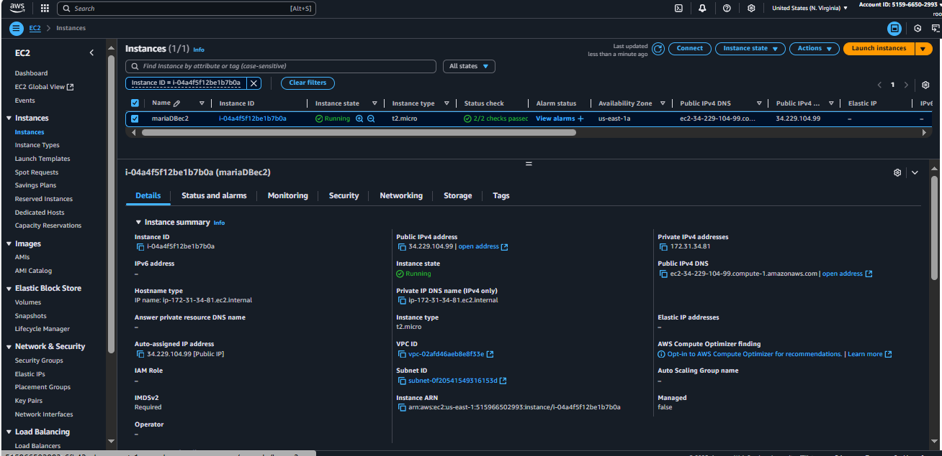

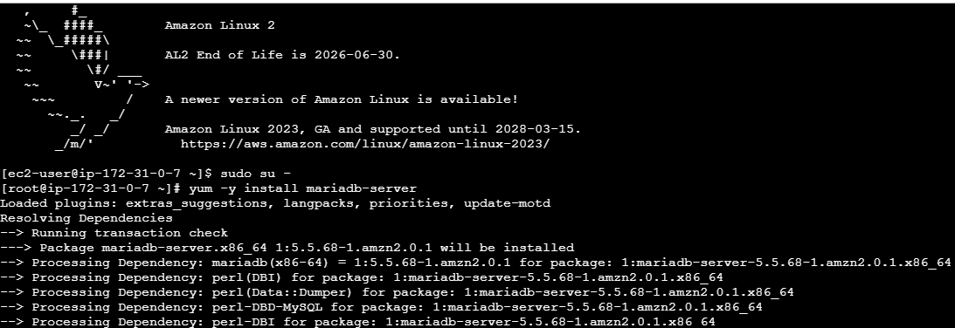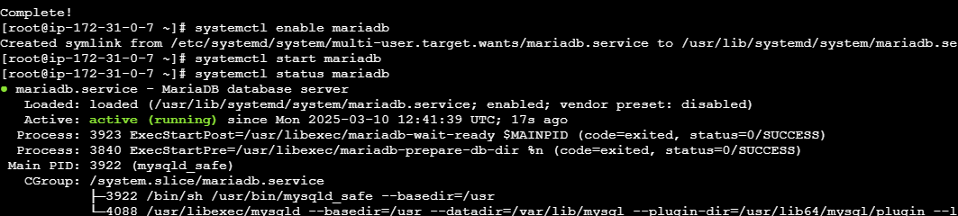

1. Insert some dummy data

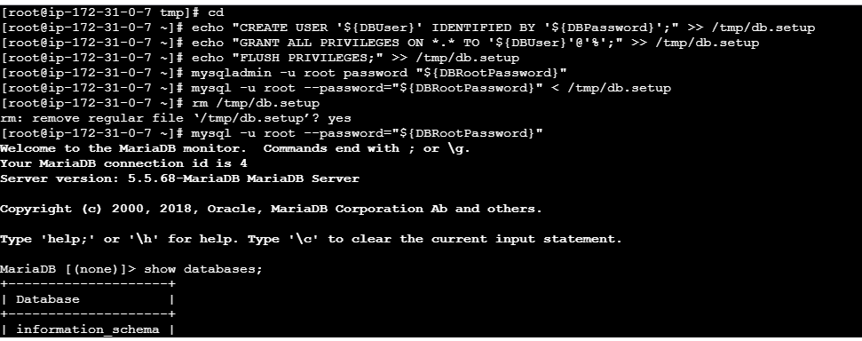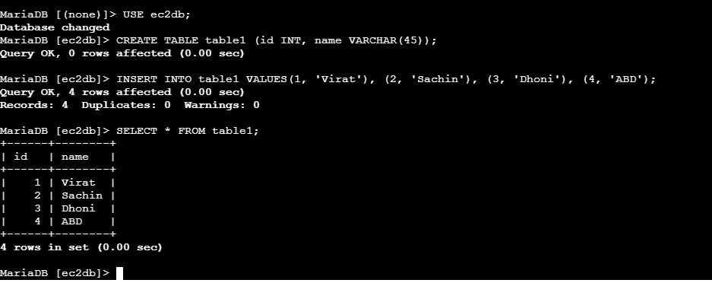

1. Take the backup of dummy data on ec2 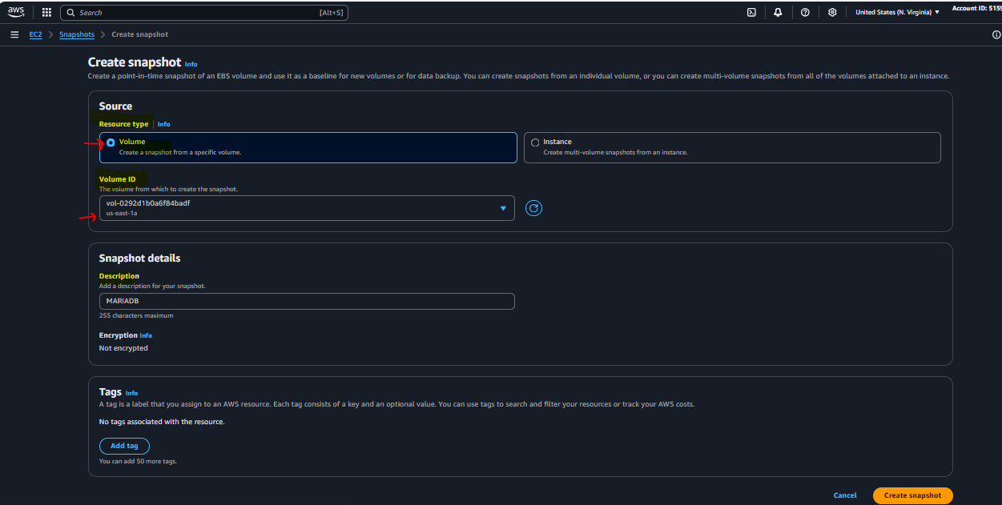

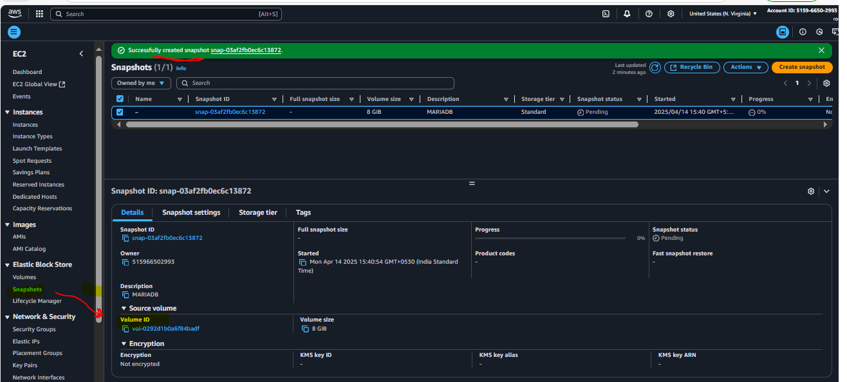

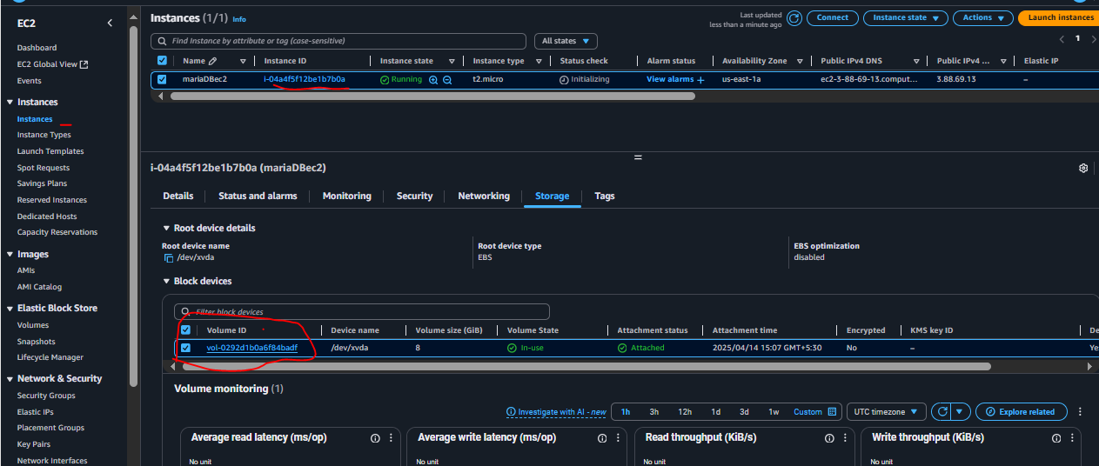

4) launch Mariadb RDS instance.

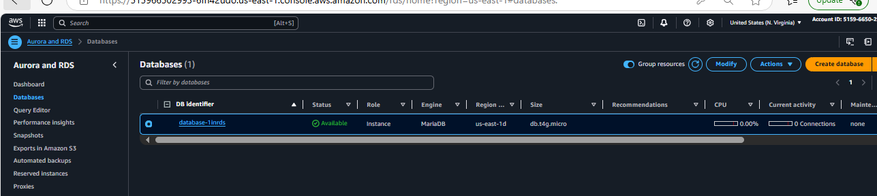

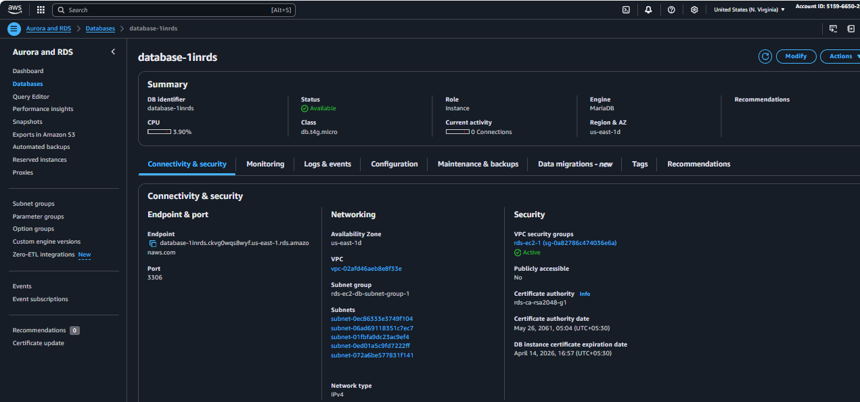

1. Migrate database from ec2 to RDS.

USE BELOW COMMANDS TO MIGRATE DATABASE FROM EC2 TO RDS

* To get the dump of your existing DB on EC2

**mysqldump -u root -p database_name > file_name.sql**

* To Migrate the DB dump

**Migrate the DB dump that you have taken in step 1 to RDS**

* To connect to your RDS DB instance **mysql -h maria-db.cz60usy2u5ru.ap-south-1.rds.amazonaws.com -P 3306 -u ec2dbuser -p maria < ec2db.sql**
* **mysql -h <replace-rds-end-point-here> -P 3306 -u rdsuser –p**
* **To switch to the database rdsdb**
* **To show the content of DB SELECT * FROM table1;**
* **mysql -u root -p –h**

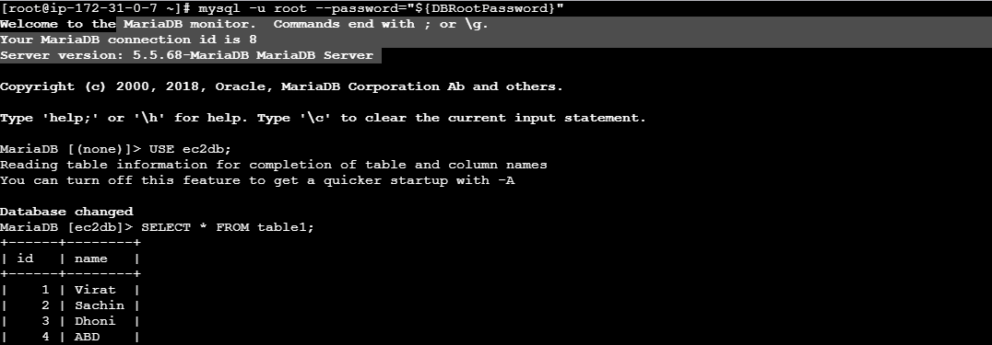

6) Install mysql db on ec2 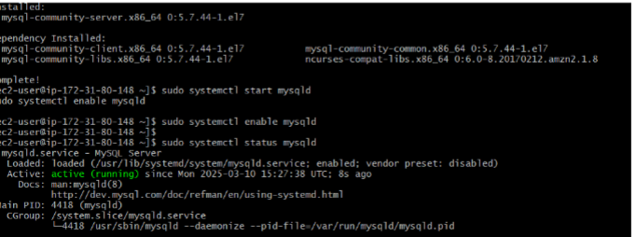7) Launch mysql RDS image 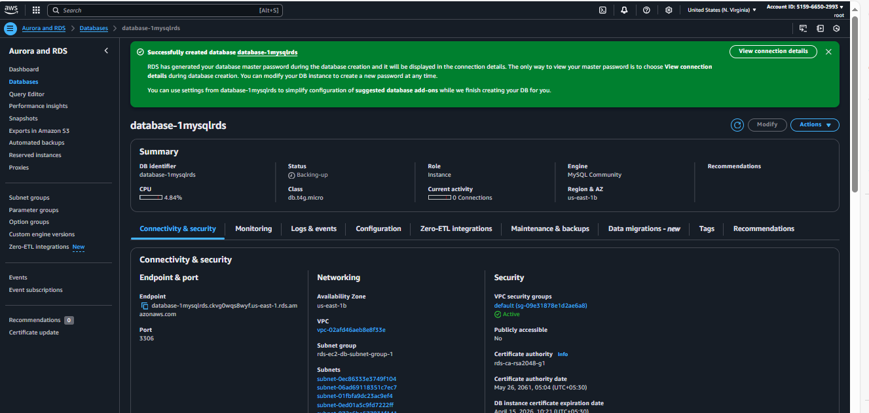

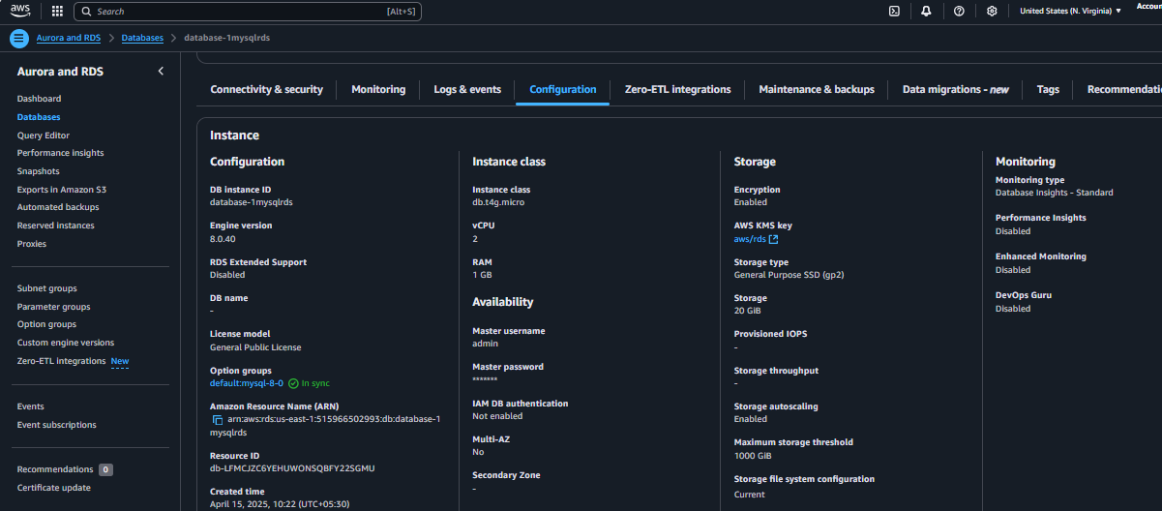

8) Configure multi AZ

**Goto RDS -🡪Databases-🡪select database-🡪Actions-🡪Convert to Multi A-Z deployment**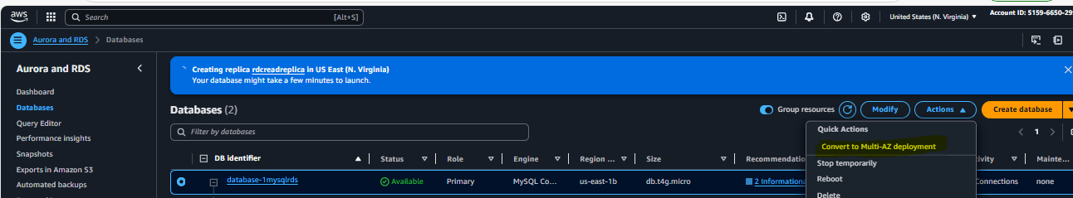 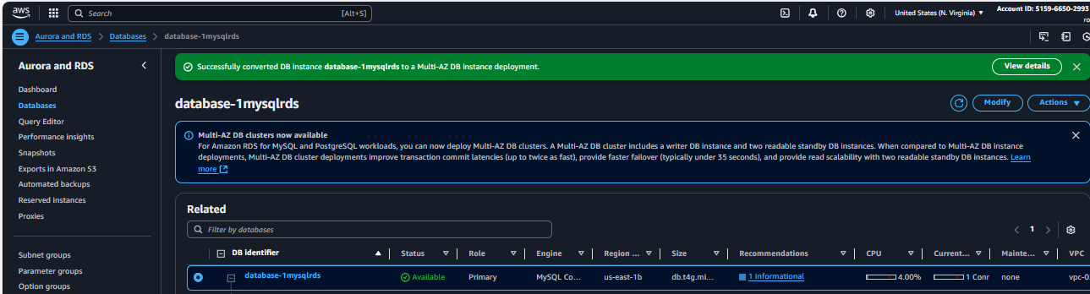

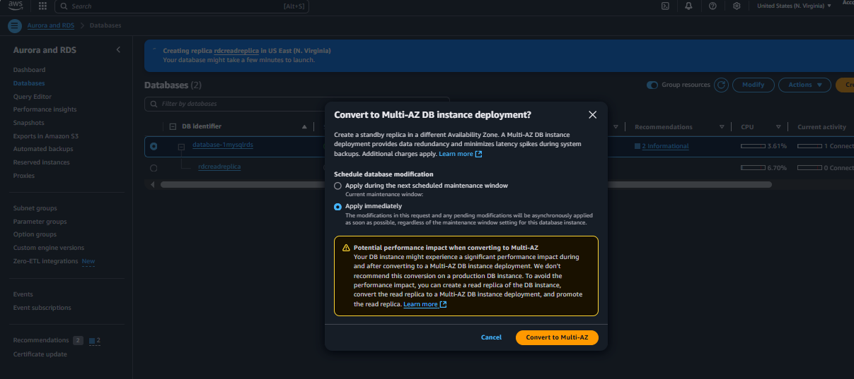 

9) Take Backup of db and restore the DB

**Select the RDS and click onn ACTIons and Select Take snapshot**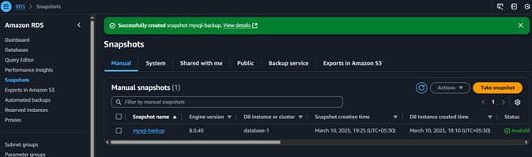

10) Create Read Replica

**Goto RDS -🡪Databases-🡪select database-🡪Actions-🡪Create Read replica**